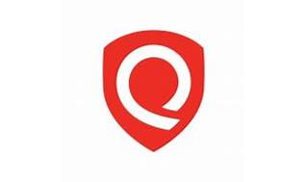

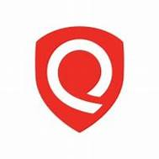

Explore

Certainly! **Qualys** is a **cloud-based solution** that detects vulnerabilities on all networked assets, including servers, network devices, peripherals, and workstations. [It proactively identifies and assesses vulnerabilities, allowing prioritized corrections before they become targets for exploitation by attackers1](https://www.qualys.com/support/faq/general/).

Here are **five free reference links** where you can learn more about Qualys:

1. [**Qualys General FAQ**](https://www.qualys.com/support/faq/general/): This page provides an overview of Qualys, its cloud-based services, and how it helps with security and compliance[1](https://www.qualys.com/support/faq/general/).
2. [**Qualys Enterprise Cyber Risk & Security Platform**](https://www.qualys.com/): Explore the unified platform that offers 20+ integrated apps for IT security and compliance across the extended enterprise[2](https://www.qualys.com/).
3. [**Qualys Certification and Training Center**](https://www.qualys.com/training/): Access free training courses with hands-on labs to learn about Qualys Suite features and best practices[3](https://www.qualys.com/training/).
4. [**Video Library: Vulnerability Management**](https://www.qualys.com/training/library/vulnerability-management/): Dive into core features of Qualys Vulnerability Management and effective VM program building[4](https://www.qualys.com/training/library/vulnerability-management/).
5. [**Qualys Free Self-Paced Training**](https://vimeo.com/228438066): Learn how to set up training accounts, register for courses, and complete labs and certifications[5](https://vimeo.com/228438066).

Feel free to explore these resources to enhance your understanding of Qualys! 🚀🔒